CS 178 Visual Analytics — Final Project Answer Sheet

Tools Used
- DuckDB – data ingestion and SQL query engine for the 13.5M row dataset
- Python / Pandas – data pipeline, pre-computation, and terminal stop flagging
- Flask – backend API server
- D3.js – interactive visualizations
- HTML / CSS – frontend interface

Question 1: Characterize the data
The dataset contains 13,583,710 departure records from the MBTA rapid transit network across all of 2025, covering 8 route IDs and 125 stations. Each record captures a single train departure at a stop, along with the headway — the time since the previous departure of the same route from that stop. Headway is the primary unit of analysis because it directly measures how long a passenger might wait for a train.

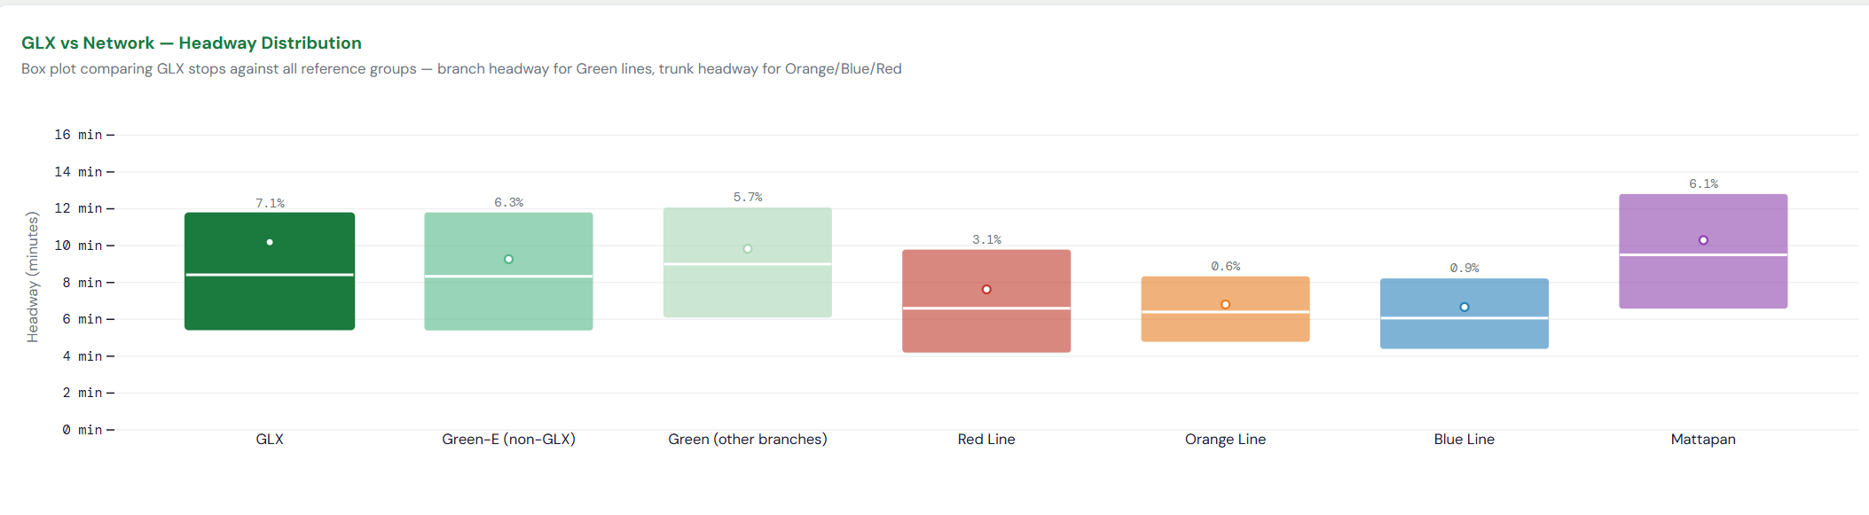
The data can be analyzed at multiple levels: individual stops, branches (e.g. Green-E, Red-A), trunk lines (e.g. Green, Red), and the full network. For the Green and Red lines, both trunk headway (all trains of that line) and branch headway (trains of a specific branch) are recorded. For Orange, Blue, and Mattapan, only trunk headway exists since they have no branches.
Figure 1
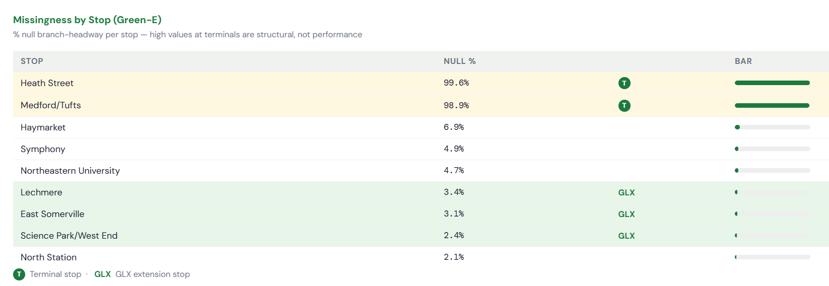
Figure 1 shows the headway distribution across all line groups. Green Line branches (GLX, Green-E non-GLX, other Green branches) cluster around 8–10 minutes. Orange and Blue lines run more frequently at 6–7 minutes. Mattapan runs the least frequently at around 10 minutes. Red Line sits in between at 7–8 minutes. GLX specifically has a median headway of around 8.5 minutes, consistent with the rest of the Green Line.
Figure 2

Figure 2 shows missingness by stop on Green-E. Heath Street (99.6% null) and Medford/Tufts (98.9% null) dominate the top of the table. These are terminal stops where trains originate. Since there is no previous departure at the same stop to measure against, no headway can be computed. This is a structural feature of how the data is collected, not a reflection of service quality. All other Green-E stops, including GLX intermediate stops, show low null rates between 1–7%.

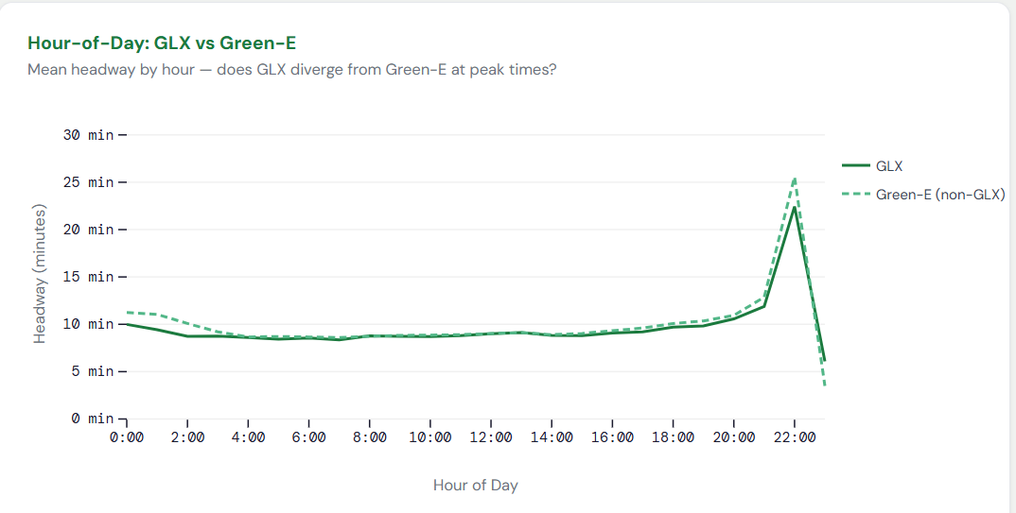
Question 2: Relationships between headways and other variables
Figure 3

Figure 3 shows mean headway by hour for GLX and Green-E non-GLX. Both lines follow the same pattern, which is slightly higher headways on early morning (0:00–5:00), dropping to their lowest around 8:00, staying stable through midday, then rising sharply after 20:00 and peaking around 22:00 at over 20 minutes before service ends. This pattern reflects scheduled service frequency. More trains run during daytime hours, fewer run late at night. GLX and Green-E non-GLX track each other almost exactly throughout the day, with no divergence at peak hours.

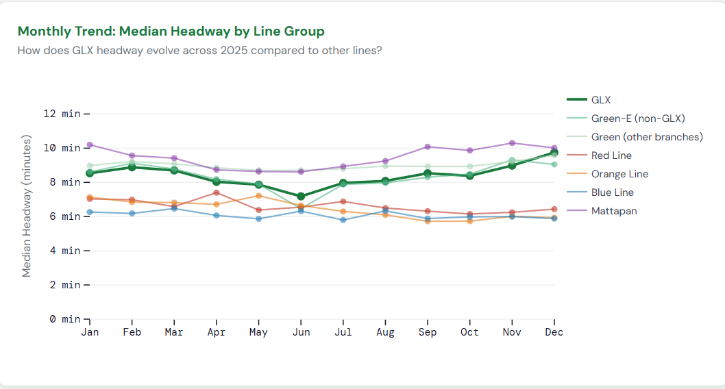
Figure 4
Figure 4 shows median headway by month for all line groups. All Green Line groups (GLX, Green-E non-GLX, other branches) move together across the year — slightly higher in winter months, dipping in summer around June–July, then rising again toward December. Orange and Blue lines show similar seasonal patterns but at lower headway levels. This suggests the seasonal variation is a network-wide phenomenon, likely related to service schedules and ridership patterns, rather than anything specific to GLX. Crucially, GLX does not diverge from other Green Line groups at any point during the year.

The network comparison (Figure 1) shows that Orange and Blue lines have consistently shorter headways than Green Line branches. This is expected, since Orange and Blue are dedicated heavy rail lines with no branching, allowing them to run more frequently. The Green Line shares its downtown trunk across four branches, which naturally increases the headway on any individual branch.

Question 3: Data issues and shortcomings
Terminal stop missingness: The most significant structural issue is the near-total null branch-headway at terminal stops. As shown in Figure 2, Medford/Tufts (98.9%) and Heath Street (99.6%) are flagged as terminals with almost no branch-headway data. This occurs because the dataset computes headway as the time since the previous departure of the same route from the same stop. But when a train originates at a terminal, there is no previous departure to reference. This is not a data error but a measurement limitation. Any analysis that naively ranks stops by average headway would incorrectly flag these terminals as outliers.
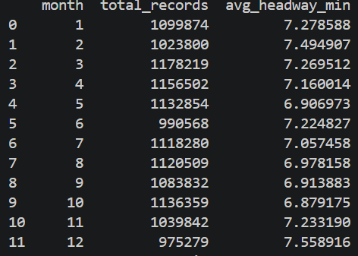
Inconsistent branch headway across lines: Orange, Blue, and Mattapan lines have no branch structure, so their branch headway field is always null. This makes direct branch-level comparisons across all lines impossible. We addressed this by using trunk headway for these lines, but this introduces a slight inconsistency — trunk headway on Green Line counts all Green trains, while branch headway counts only one branch's trains. These are not the same metric.
Figure 5
Data completeness gaps: The monthly trend chart (Figure 4) and monthly record (Figure 5) shows a dip across all line groups in June, which is approximately 10% fewer records than typical months alongside lower median headways. It is unclear whether this reflects a genuine service improvement, a seasonal schedule change, or a data completeness gap. December shows a similar record count drop but higher headways, suggesting fewer records don't always indicate missing data. This ambiguity is a limitation of the dataset: without scheduled headway data, we cannot distinguish real service changes from data collection gaps.

